2. Latency measurement of ESP 32 Microcontroller(Practical)

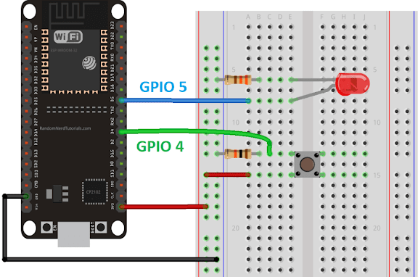

1.Plug a male to male wire from 3V3 to positive side of breadboard
2. Plug a male to male wire from postive side of breadboard to a push button
3. Plug a 10k Ohm resistor beside the other pin of the push button
4. Plug a male to male wire from the push button to ESP32 on any GPIO 4 pin you want
5. Plug a LED to ESP32 and put a 220 Ohm resistor next to it
6. Plug a male to male wire from GND to negative side of breadboard

Code:

#include <Arduino.h>

#define GPIO_INPUT_PIN 5 // Input pin to trigger the interrupt(LED)
#define GPIO_OUTPUT_PIN 4 // Output pin to measure latency(push button)

volatile uint32_t start_time = 0; // Stores the time when the interrupt is triggered
volatile uint32_t end_time = 0; // Stores the time when the ISR starts executing
volatile uint32_t latency = 0; // Stores the calculated interrupt latency

void IRAM_ATTR handleInterrupt() {
// Read the current time in microseconds
end_time = micros();
// Calculate the latency
latency = end_time - start_time;

// Toggle the output pin for visual indication (optional)
digitalWrite(GPIO_OUTPUT_PIN, !digitalRead(GPIO_OUTPUT_PIN));
}

void setup() {
// Configure the input pin
pinMode(GPIO_INPUT_PIN, INPUT_PULLUP);
// Configure the output pin
pinMode(GPIO_OUTPUT_PIN, OUTPUT);

// Attach interrupt to the input pin
attachInterrupt(GPIO_INPUT_PIN, []() {
start_time = micros(); // Record the time when interrupt is triggered
handleInterrupt(); // Call the ISR
}, FALLING);

// Start serial communication
Serial.begin(115200);
}

void loop() {
// Print the interrupt latency periodically
if (latency > 0) {
Serial.print("Interrupt Latency: ");
Serial.print(latency);
Serial.println(" microseconds");
latency = 0; // Reset for the next measurement
}

delay(1000); // Short delay to prevent spamming the Serial Monitor
}

2. Interrupt handling of ESP 32 Microcontroller.(skill)

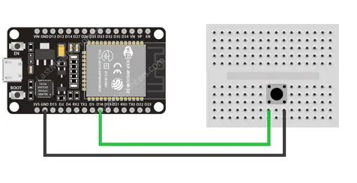
Code:
struct Button {
const uint8_t PIN;
uint32_t numberKeyPresses;
bool pressed;
};

Button button1 = {18, 0, false};

void IRAM_ATTR isr() {
button1.numberKeyPresses++;
button1.pressed = true;
}

void setup() {
Serial.begin(115200);
pinMode(button1.PIN, INPUT_PULLUP);
attachInterrupt(button1.PIN, isr, FALLING);
}
void loop() {
if (button1.pressed) {
Serial.printf("Button has been pressed %u times\n", button1.numberKeyPresses);
button1.pressed = false;
}
}

